Bloomberg - Artificial Intelligence Essentials

Contents

Introduction to Artificial Intelligence 1

Machine Learning and Deep Learning 7

## Introduction to Artificial Intelligence

<https://ole03.yourlearning.ibm.com/mod/scorm/player.php?a=661&currentorg=articulate_rise&scoid=2831&display=popup&mode=normal&lang=en>

1. **What is the difference between AI and augmented intelligence?**

* When learning about artificial intelligence, you’ll come across the term augmented intelligence. Both terms share the same objective, but have different approaches. Augmented intelligence has a modest goal of helping humans with tasks that are not practical to do. For example, “reading” 1000 pages in an hour. In contrast, artificial intelligence has a lofty goal of mimicking human thinking and processes. However, it’s important to note that AI today is not mature enough to perform independent tasks such as diagnosing cancer.
* Artificial intelligence (AI) refers to the ability of a machine to learn patterns and make predictions. AI does not replace human decisions. Instead, AI adds value to human judgment.
* The word that best describes what AI can do is predict.

1. **How is AI evolving?**

Narrow AI

* Narrow AI is focused on addressing a single task such as predicting your next purchase or planning your day.
* Narrow AI is scaling very quickly in the consumer world, in which there are a lot of common tasks and data to train AI systems. For example, you can buy a book with a voice-based device.
* Narrow AI also enables robust applications, such as using Siri on an iPhone, the Amazon recommendation engine, autonomous vehicles, and more. Narrow AI systems like Siri have conversational capabilities, but only if you stick to the script.

Broad AI

* Broad AI is a midpoint between Narrow and General AI.
* Rather than being limited to a single task, Broad AI systems are more versatile and can handle a wider range of related tasks.
* Broad AI is focused on integrating AI within a specific business process where companies need business- and enterprise-specific knowledge and data to train this type of system.
* Newer Broad AI systems predict global weather, trace pandemics, and help businesses predict future trends.

General AI

* General AI refers to machines that can perform any intellectual task that a human can.
* Currently, AI does not have the ability to think abstractly, strategize, and use previous experiences to come up with new, creative ideas as humans do, such as inventing a new product or responding to people with appropriate emotions. And don't worry, AI is nowhere near this point.

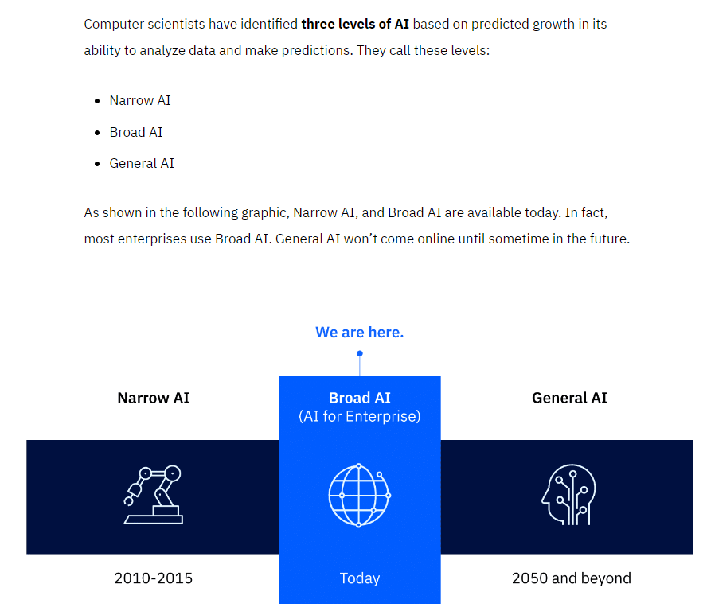

There might be another level, known as artificial superintelligence (ASI) that could appear near the end of this century. Then machines might become self-aware! Even then, no levels of AI are expected to replace or dominate you. Instead, scientists hope AI will extend humans’ ability to lead richer lives.

1. A brief history of AI

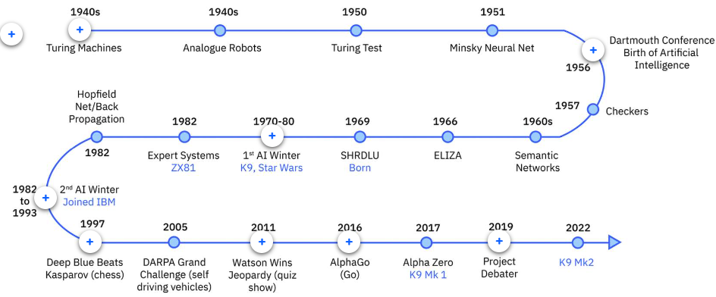

* The Era of AI began one summer in 1956
* High expectations and lack of funding were the main causes of the First Winter of AI.
* The three eras of computing, in order, are: the Era of Tabulation, the Era of Programming, and the Era of AI.
* During the turmoil of World War II, a new approach to data emerged, called the Era of Programming, that could run more than one kind of instruction (called "programs" today) in order to do more than one kind of calculation. Programmable computers guided astronauts from Earth to the moon during this era.
* The Era of Tabulation was a time when machines helped humans sort data into structures to reveal its secrets, revealing more than just simply counting a sum total.

1. Today, about 80% of the world’s data is unstructured.
2. Data can be organized into the following three types.

* Structured data is typically categorized as quantitative data and is highly organized. Structured data is information that can be organized in rows and columns. Perhaps you've seen structured data in a spreadsheet, like Google Sheets or Microsoft Excel. Examples of structured data includes names, dates, addresses, credit card numbers, stock information.
* Unstructured data, also known as dark data, is typically categorized as qualitative data. It cannot be processed and analyzed by conventional data tools and methods. Unstructured data lacks any built-in organization, or structure. Examples of unstructured data include images, texts, customer comments, medical records, and even song lyrics.
* Semi-structured data is the “bridge” between structured and unstructured data. It doesn't have a predefined data model. It combines features of both structured data and unstructured data. It's more complex than structured data, yet easier to store than unstructured data. Semi-structured data uses metadata to identify specific data characteristics and scale data into records and preset fields. Metadata ultimately enables semi-structured data to be better cataloged, searched, and analyzed than unstructured data. An example of semi-structured data is a video on a social media site. The video by itself is unstructured data, but a video typically has text for the internet to easily categorize that information, such as through a hashtag to identify a location.

1. Machine learning is a type of AI with advantages over programmable computers. Machine learning can predict and learn!

* A distinguishing feature of machine learning is that it can analyze dark data, also known as unstructured data, much more quickly than a programmable computer can.
* Programmable computing requires Tomas to manually enter every possible route in a database. Machine learning only requires him to provide city locations; it can find routes, by itself, as needed.

1. Machine learning solves problems in three ways:

* Supervised learning
* Unsupervised learning
* Reinforcement learning

1. Supervised learning is about providing AI with enough examples to make accurate predictions.

* All supervised learning algorithms need labeled data. Labeled data is data that is grouped into samples that are tagged with one or more labels. In other words, applying supervised learning requires you to tell your model:
  + What the key characteristics of a thing are, also called features
  + What the thing actually is

1. In unsupervised learning, a person feeds a machine a large amount of information, asks a question, and then the machine is left to figure out how to answer the question by itself.

* For example, the machine might be fed many photos and articles about dogs. It will classify and cluster information about all of them. When shown a new photo of a dog, the machine can identify the photo as a dog, with reasonable accuracy.
* Unsupervised learning occurs when the algorithm is not given a specific “wrong” or “right” outcome. Instead, the algorithm is given unlabeled data.
* Recommendation engines, such as those used by YouTube and Netflix, use unsupervised learning to find hidden patterns in user data.

1. Reinforcement learning is a machine learning model similar to supervised learning, but the algorithm isn’t trained using sample data. This model learns as it goes by using trial and error. A sequence of successful outcomes is reinforced to develop the best recommendation for a given problem. The foundation of reinforcement learning is rewarding the “right” behavior and punishing the “wrong” behavior.

* You might be wondering, what does it mean to "reward" a machine? Good question! Rewarding a machine means that you give your agent positive reinforcement for performing the "right" thing and negative reinforcement for performing the "wrong" things.
* As a machine learns through trial and error, it tries a prediction, then compares it with data in its corpus.
  + Each time the comparison is positive, the machine receives positive numerical feedback, or a reward.
  + Each time the comparison is negative, the machine receives negative numerical feedback, or a penalty.

1. Netflix Recommendations are typically made using Narrow AI. Narrow AI looks at a user’s preferences, with respect to a database of content or information, and determines their likes and dislikes.

* 总的来说，广告的推荐一般是Narrow AI领域和unsupervised learning的

1. In Broad AI systems, several narrow systems combine to make more complex predictions.

* Tesla cars are all connected and share what they learn when autonomously driving. This is an example of Board AI
* Tesla combines each car’s driving experience to increase the amount of data available to each car’s AI.

1. AI researchers expect General AI to emerge around 2050. General AI will enable supersmart bots and technologies to link AI with the Internet of Things through “embodied cognition”.
2. Instrumented planet refers to the idea of billions of sensors generating exabytes of data that will open new possibilities for improving Earth’s safety, sustainability, and security.

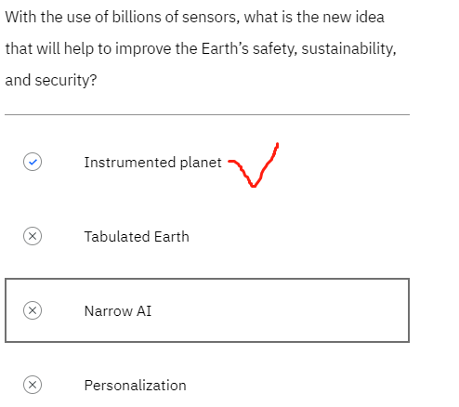

1. AI everywhere is the idea of how AI in the future will move into all industries, from finance, to education, to healthcare. AI is expected to increase productivity and enable new opportunities.
2. General AI refers to machines that can perform any intellectual task that a human can. Unlike Narrow AI, which is limited to specific tasks, General AI has the ability to think abstractly, strategize, and use previous experiences to come up with new ideas.
3. Key points to remember

* Artificial intelligence refers to the ability of a machine to learn patterns and make predictions. AI does not replace human decisions; instead, AI adds value to human judgment.
* AI performs tasks without human intervention and completes mundane and repetitive tasks, while augmented intelligence allows humans to make final decisions after analyzing data, reports, and other types of data.
* The three levels of AI include: Narrow AI, Broad AI, and General AI. Narrow AI and Broad AI are available today. In fact, most enterprises use Broad AI. General AI won’t come online until sometime in the future.
* The history of AI has progressed across the Era of Tabulation, Era of Programming, and Era of AI.
* Data can be structured, unstructured, or semi-structured.
  + Structured data is quantitative and highly organized, such as a spreadsheet of data.
  + Unstructured data is qualitative data that doesn't have structure, such as medical records. It's becoming increasing valuable to businesses.
  + And semi-structured data combines features of both structured data and unstructured data. It uses metadata.
* About 80% of all the data in today’s world is unstructured.
* Machine learning has advantages compared to programmable computers. Machine learning can predict and machine learning learns!
* Machine learning uses three methods.
  + Supervised learning requires enough examples to make accurate predictions
  + Unsupervised learning requires large amounts of information so the machine can ask a question, and then figure out how to answer the question by itself.
  + Reinforcement learning requires the process of trial and error.
* With AI everywhere, AI will move into all industries, from finance, to education, to healthcare.
* AI can increase productivity, create new opportunities, provide deeper insights, and enable personalization.

1. Social media data is semi-structured, meaning it has features of both structured and unstructured data. Semi-structured data doesn’t have a predefined data model.
2. Machine learning can analyze unstructured data more quickly than a programmable computer because machine learning doesn’t rely on programming instructions to work with unstructured data.
3. Machine learning is probabilistic. It never says “YES” or “NO”. Machine learning is analog (like waves gradually going up and down) rather than binary (like a coin flip).

## Machine Learning and Deep Learning

1. To find out, you'll explore three categories of AI:

* The term artificial intelligence describes computer systems that can apply reasoning to subjects that previously required human intelligence.
* Machine learning can enable systems to predict and classify given data in response to ever-changing data, somewhat like the way you learn from experience.
* Deep learning is a group of extremely powerful types of machine learning, many of which are inspired by the operation of neural networks in the human brain.

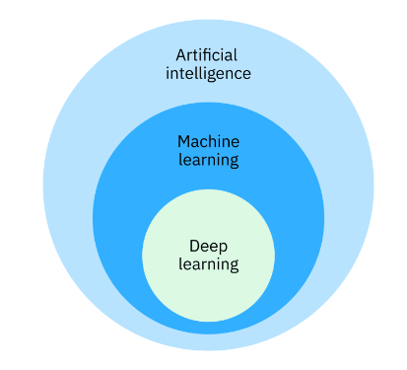

1. Supervised learning requires that an AI system ingest structured data. Unsupervised learning and reinforcement learning require a system to develop its own structure either by analyzing large amounts of data (unsupervised learning) or by trial-and-error (reinforcement learning).
2. Classical machine learning began in the 1950s. AI systems learned by ingesting data and getting better at recognizing patterns. The AI systems could predict things like the distance between points or the intensity of values.

* Like all machine learning, the classical form depends on algorithms. Recall that algorithms are mathematical expressions that output a result. Classical machine learning uses a small number of algorithms in a relatively simple arrangement. Sometimes machine learning algorithms are binary, which means that they output one of only two values. Typical binary results might be a 1 or a 0, a YES or a NO, and a TRUE or a FALSE.
* Other classical learning algorithms are more complicated. For example, their result might be represented as a position on a multidimensional graph rather than “this point” or “that point”. Here are three typical algorithms that are used in classical computing:
  + Decision tree
  + Linear regression
  + Logistic regression

1. Classical machine learning can be outperformed, at some tasks, by newer methods that are part of the deep learning ecosystem. But there are still reasons to use classical machine learning:

* Work with structured data
* Lower expense to operate - Classical machine learning requires less computing power than deep learning ecosystems. They can run on less expensive computers with less powerful processors, which lowers the price for smaller businesses, communities, or healthcare systems that share time on them in pay-as-you-go arrangements.
* Easier to interpret - Deep networks are so complex that even AI researchers don’t entirely understand what’s going on inside. As a result, AI researchers are not always able to determine when deep network systems are producing invalid outputs. Compared to these mysteries, classical results can be easier to debug, and to test for accuracy and lack of bias.

1. A decision tree is a supervised learning algorithm. It operates like a flowchart. You can think of a flowchart as an upside-down decision tree. The flowchart has a root node (where the flowchart begins), branches that connect to internal nodes, and more branches that connect to leaf nodes.
2. Linear regression is another type of algorithm. It relates to data that might be graphed as a straight line.
3. In some situations, a relationship does not fall in a straight line. Sometimes a system uses values that require a specific, limited kind of outcome, such as something between 0 and 1 (or NO and YES). In this situation, a graph can form what’s called a sigmoid function, or an S-shaped curve. For any set of variables, the outcome (which is a point on the S-curve) falls between 0 and 1.

* A logistic regression answers a question such as “If this increases by X, will the value of Y be closer to 0 or 1?”

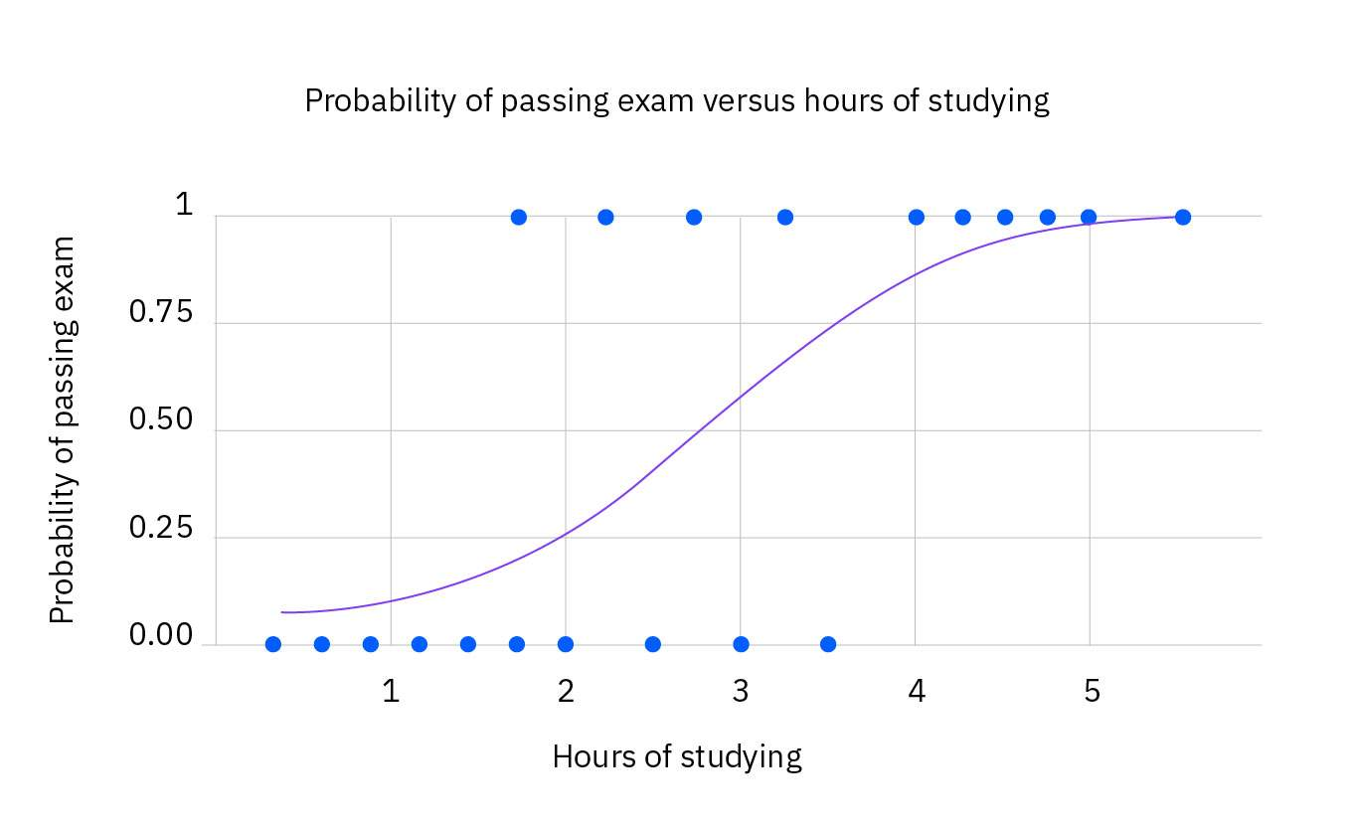

1. Many forms of deep neural network (DNN) devices make up the modern deep learning ecosystem.
2. Neural networks were inspired by the complex way neurons communicate in the human brain.
3. Generative AI is a type of artificial intelligence that creates new, original content that people have never seen before.

* Most AI systems are discriminative AI models, which predict and classify data.
* In contrast, generative AI models are a type of deep learning AI system that uses algorithms to generate content based on a submitted prompt, thus the name of generative AI.
* So, generative AI’s distinction from other AI systems is its ability to produce content that is new and considered creative, such as images, videos, music, synthetic data, essays, answers to questions, and more.

1. 3 primary types of generative AI models:

* Variational autoencoder (VAE)
* Generative adversarial network (GAN)
* Autoregressive

1. VAEs use a similar process. The "encoder" network compresses the input data into a lower-dimensional representation and the "decoder" network reconstructs the original data from this compressed representation. This allows VAEs to capture the underlying structure and patterns in the data, which can then generate new, similar data.
2. Think of a generative adversarial network (GAN) model as a competition between a skilled forger (the generator) and a talented art critic (the discriminator). The forger creates fake paintings, while the critic tries to determine whether each painting is genuine or a forgery. As the forger improves their technique, the critic becomes more discerning, and this cycle continues until the forger can create near-perfect forgeries.

* In GANs, the generator creates new data, while the discriminator evaluates the quality of the generated data. The generator tries to create data that is realistic enough to fool the discriminator, while the discriminator learns to better distinguish between real and generated data. This competition leads to the generator creating increasingly realistic content.

1. Imagine an autoregressive model as a skilled storyteller who listens to the beginning of a story and then continues it by predicting what comes next based on the words and events that have occurred so far. The storyteller uses their knowledge of language, grammar, and storytelling conventions to create a coherent and engaging continuation of the story.

* Autoregressive models generate new content by predicting the next element in a sequence based on the previous elements. They are particularly well-suited for generating text because they can model the conditional probabilities of words and characters in a sentence.

1. Limitations of generative AI

* Lack of originality: Generative AI models rely on large datasets to learn and generate content. As a result, they might not create entirely original content but rather mimic patterns from their training data, which can lead to a lack of creativity and innovation.
* Incompleteness: While generative AI models are becoming increasingly sophisticated, they still struggle to understand the nuanced contexts and might generate incomplete or nonsensical content.
* Bias: Generative AI models can perpetuate existing biases present in their training data, leading to the generation of biased content that might reinforce stereotypes and discriminatory behavior.
* Computational resources: Training and deploying generative AI models require significant computational power, which can be expensive and contribute to environmental concerns such as energy consumption and carbon emissions.

1. Ethical concerns of generative AI

* Misinformation and fake content: Generative AI can create convincing fake content, like deepfakes or falsified news articles, which can lead to the spread of misinformation and have severe consequences for individuals and societies.
* Intellectual property and copyright: Generative AI can produce content that resembles copyrighted material. This raises questions about intellectual property rights and potential infringements.
* Privacy: Generative AI can create realistic images and text about individuals, potentially violating their privacy and causing harm to their reputation.
* Loss of human touch: As generative AI becomes more prevalent, there is a risk that the human touch will be lost in various creative domains, potentially leading to a decline in the appreciation of human-created art and culture.
* Unemployment and job displacement: The rise of generative AI might lead to job displacement in creative industries, as machines take over tasks previously performed by humans.

1. data scientists and programmers are already working on the third level, called General AI. The goal of General AI is to create systems that can perform any intellectual task that a human being can—and more. Some scientists believe that this goal may be reached in about twenty years (the early 2040s).
2. An instrumented planet involves AI’s ability to improve the welfare of Earth, as a whole.

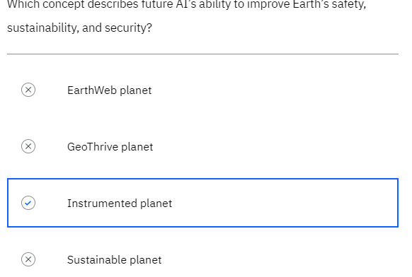

1. Personalization will enable machines to interact with you in ways tailored to your particular desires, habits, and level of comfort.

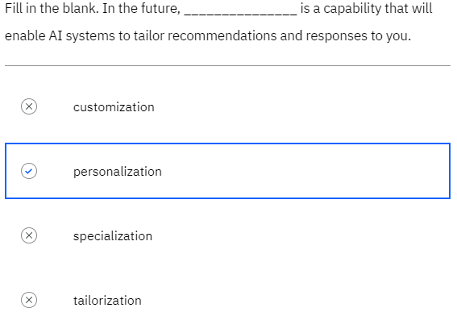

1. Key points to remember

* Using advanced mathematics, machines can learn either in classical ways or with neural networks.
* Machines can learn from structured or unstructured data and teach themselves through trial-and-error.
* Machine learning tools include logic meth
* ods, such as decision trees, linear regression, and logistic regression.
* Neural networks, inspired by the human brain, build perceptrons with layers of algorithm nodes to perform complex calculations.
* Multiple groups of multilayer perceptrons, arranged in different ways, extend machine learning in the deep learning ecosystem.
* Today, people carry on simple conversations with machine learning AI systems using what is known as Broad AI.
* Generative AI has gained attention worldwide as a revolutionary change for creating new and unique content.
* In the future, General AI systems will perform unprecedented levels of analysis to help humans improve life on a global scale.